**Lab # 9**

**Statement Purpose:**

Objective of this lab is to understand the interfaces and services of different cloud platforms including Amazon Web Services, Google Cloud Platform and Microsoft Azure.

**Activity Outcomes:**

Students will be able to:

* Understand and compare different cloud platforms.

**Instructor Note:**

All the interfaces of the public clouds and creating a basic machine on them is discussed here. The students must pay attention to the details as these are the basics with different names in any cloud. Once the students understand these terminologies and functionalities, they will be able to work on any cloud platform including digitalocean, rackspace, linode, Alibaba cloud etc.

**Introduction:**

## There are many public cloud platforms. Amazon Web Services (AWS), Microsoft Azure, and Google Cloud Platform (GCP) are being discussed in this lab. This lab manual has already discussed the basics of a virtual machine. The students must be well aware of that. Here, in this lab, students will create virtual machine instances on public cloud platforms discussed above. In AWS, this instance is called Elastic Compute Cloud (EC2). In Azure, this instance is called “Virtual Machine (VM)”, and In GCP, it is known as “VM Instance”. Other services names are being discussed in the second task of this lab.

## Mostly these instances are charged as per hour billing, known as per-use. The user is only charged for the amount of time the instance is being run. To make it clear, the charging is based on the amount of time the instance is being run, not the time when the user is actively working on it. To create these instances, the requirements to be specified are Memory, Storage, vCPUs or CPUs, SSH Keys, Region, and Zone. Clouds have their different flavors available with certain specifications for the user to choose according to the requirements. Let’s create instances in different cloud platforms in task 1.

**Lab Tasks:**

**Task 1: Creating Instances on different cloud platforms.**

## **Login and access to AWS services**

* Login to the AWS account and go to the AWS Services tab at the top left corner.
* Here, all of the AWS Services are categorized as per their area viz. Compute, Storage, Database, etc.

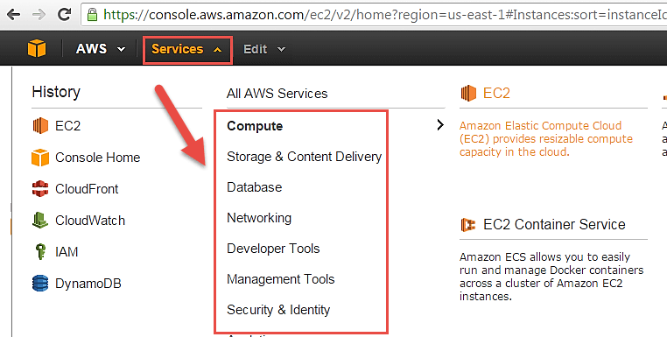

* Open all the services and click on EC2 under Compute services. This will launch the dashboard of EC2.
* EC2 dashboard is shown in the figure below. Here, all the information about the AWS EC2 resources running.

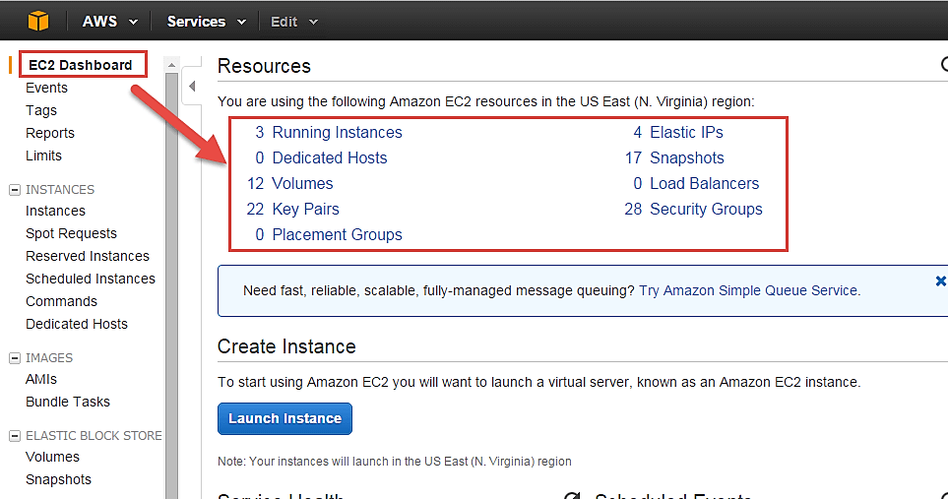

* On the top right corner of the EC2 dashboard, choose the AWS Region to provision the EC2 server.
* Here we are selecting N. Virginia. AWS provides 10 Regions all over the globe, or any one.

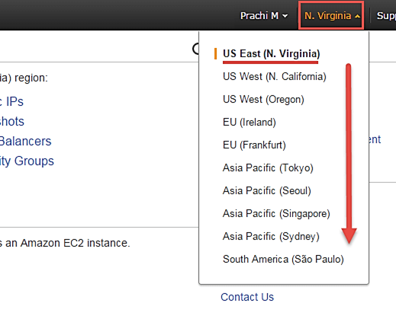

* Once the desired Region is selected, come back to the EC2 Dashboard.
* Click on the ‘Launch Instance’ button in the section of Create Instance (as shown below).

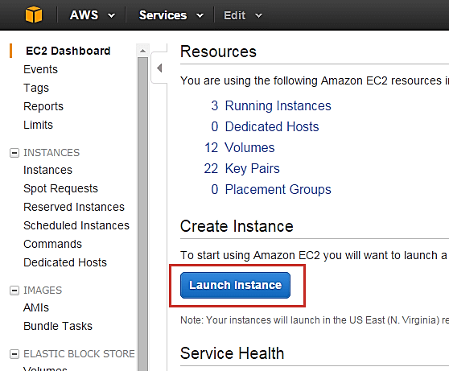

* The Instance creation wizard page will open as soon as you click ‘Launch Instance’.

# 

# **Create a Linux virtual machine in the Azure portal**

Azure virtual machines (VMs) can be created through the Azure portal. The Azure portal is a browser-based user interface to create Azure resources. This quickstart shows you how to use the Azure portal to deploy a Linux virtual machine (VM) running Ubuntu 18.04 LTS. To see your VM in action, you also SSH to the VM and install the NGINX web server.

## 

## **Sign in to Azure**

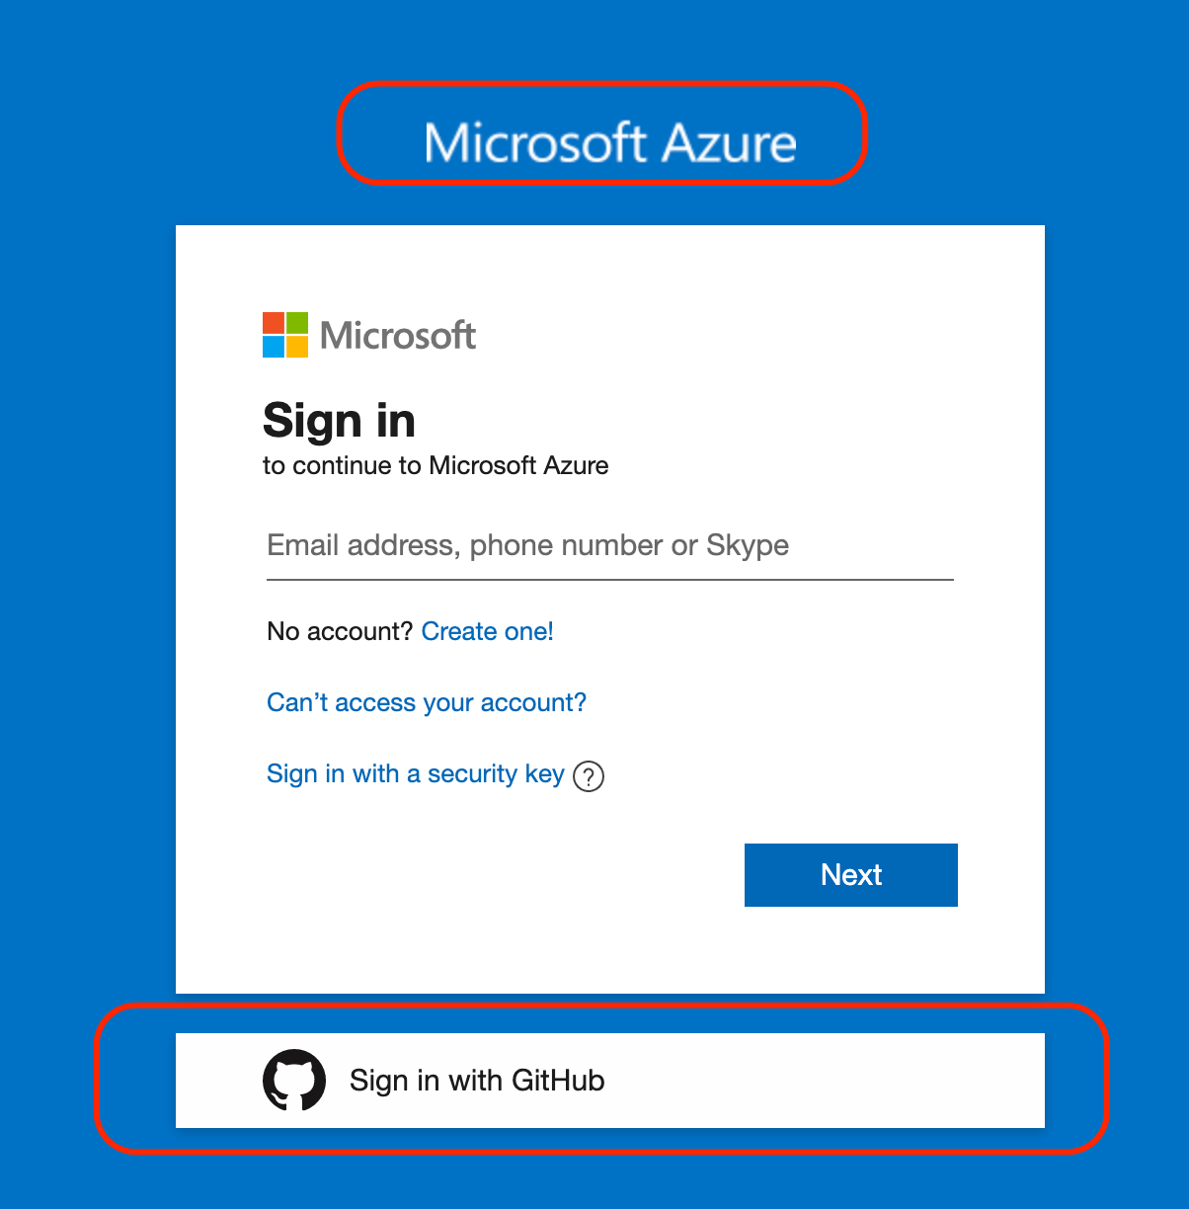

## **Create virtual machine**

1. Type virtual machines in the search.
2. Under Services, select Virtual machines.
3. In the Virtual machines page, select Create
4. Then select Virtual machine. The “Create a virtual machine” page opens.
5. In the Basics tab, under Project details, make sure the correct subscription is selected and then choose to “Create new” resource group. Type *myResourceGroup* for the name.*.

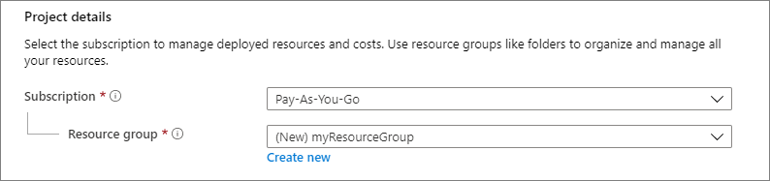

1. Under Instance details, type myVM for the Virtual machine name, and choose Ubuntu 18.04 LTS - Gen2 for your Image. Leave the other defaults. The default size and pricing is only shown as an example. Size availability and pricing are dependent on your region and subscription.

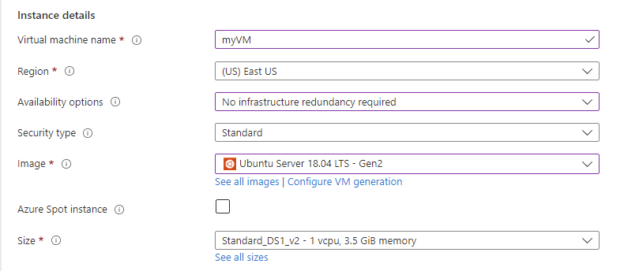

1. Under Administrator account, select SSH public key.
2. Type Username “azureuser”
3. For the SSH public key source, leave the default value “Generate new key pair”
4. Then type myKey for the Key pair name.

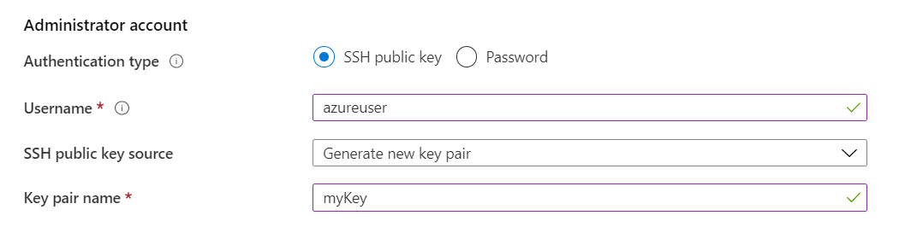

1. Under Inbound port rules > Public inbound ports, choose Allow selected ports and then select SSH (22) and HTTP (80) from the drop-down.

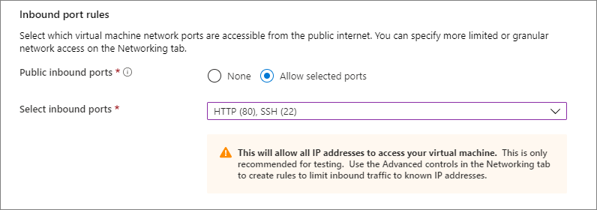

1. Leave the remaining defaults and then select the Review + create button at the bottom of the page.
2. On the Create a virtual machine page, you can see the details about the VM you are about to create. When you are ready, select Create.
3. When the Generate new key pair window opens, select Download private key and “create resource”. the key file will be downloaded as myKey.pem. Remember the path where the .pem file is downloaded. The path will be required in the next step.
4. When the deployment is finished, select “Go to resource”.
5. On the page for new VM, select the public IP address and copy it to your clipboard.

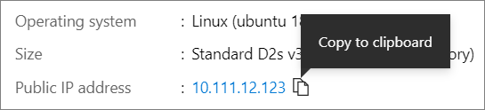

## **Connect to virtual machine**

Create an SSH connection with the VM.

1. If the machine that is connecting is a Mac or Linux machine, open a Bash prompt. If the machine is a Windows machine, open a PowerShell prompt.
2. At the prompt, open an SSH connection to the virtual machine. Replace the IP address with the one from the one copied from the created VM, and replace the path to the .pem with the path to where the key file is downloaded.

ssh -i .\Downloads\myKey.pem azureuser@10.111.12.123

## **Creating an instance in Google Cloud Platform**

**Log in to** [**Google Cloud Console**](https://console.cloud.google.com/)**.**

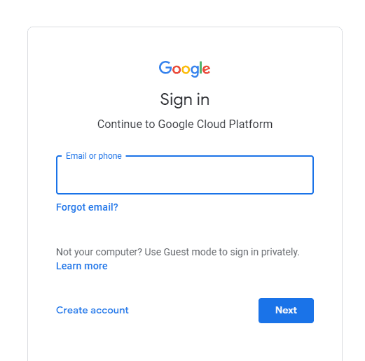

Click on ‘Navigation Menu’ and select ‘Compute Engine’ -> ‘VM instances’.

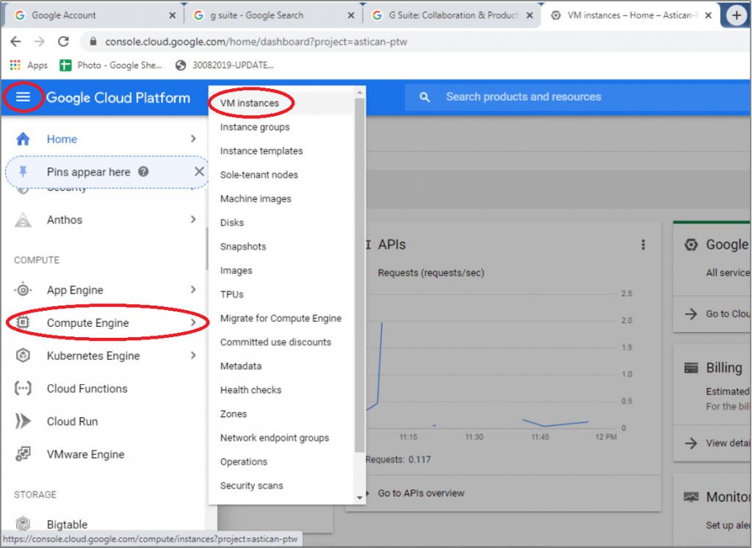

If creating an instance for the first time, a prompt to create a project will appear. Each instance belongs to a Google Cloud Project, which can have one or more instances. Enter your project name (e.g., ‘My Project 73416’), select Billing Account, and click on the ‘Create’ button.

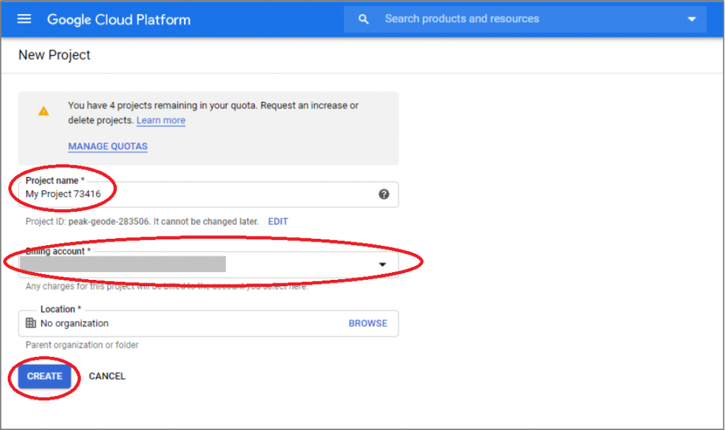

Or, if a project is already created, select it and continue.

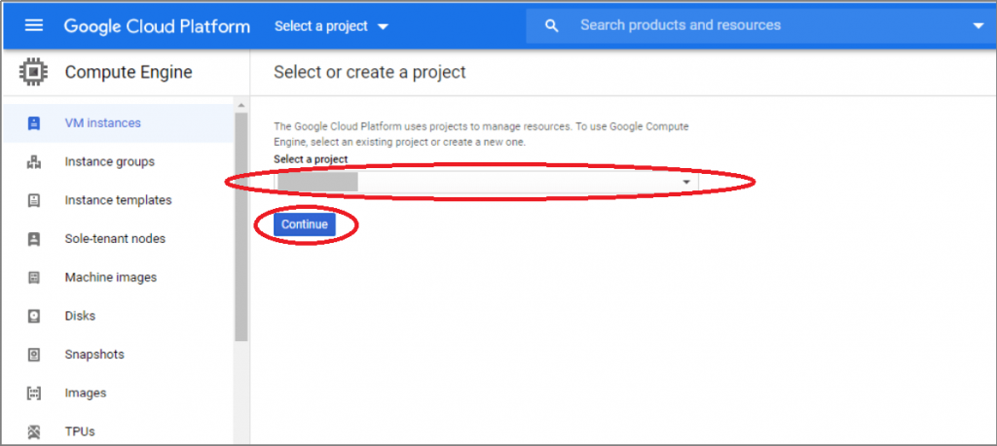

#### 

Selected project name will appear in the top bar of the screen. Click on the ‘Create’ button of the ‘Compute Engine – VM Instances’ pop-up window, and the ‘Create an instance’ screen will appear.

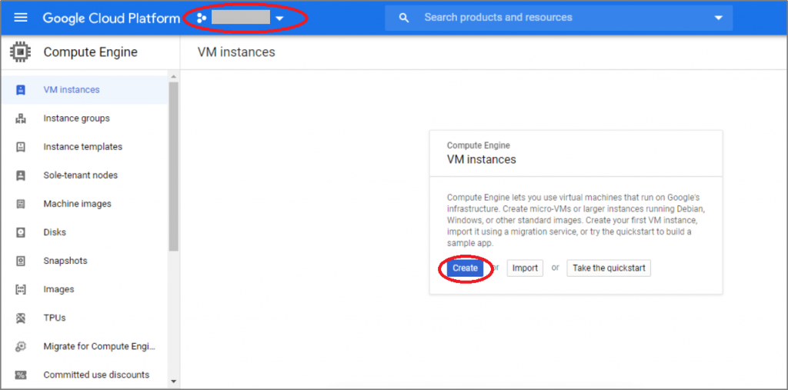

#### 

Type an instance name that is identifiable name for the instance (e.g., Instance 1).

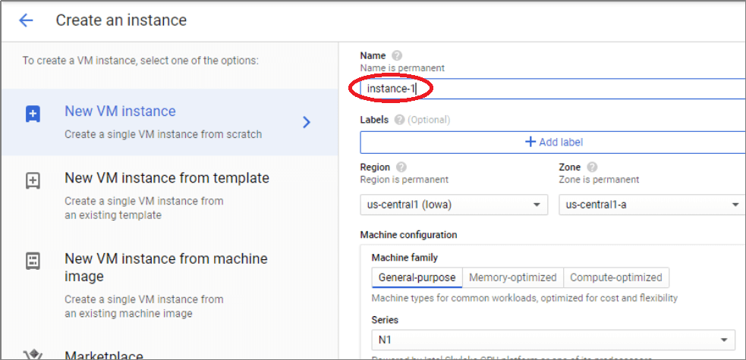

#### 

Next, select the ‘Region’ and ‘Zone’. Please note that these are permanent settings and hence, need careful consideration while selecting them.

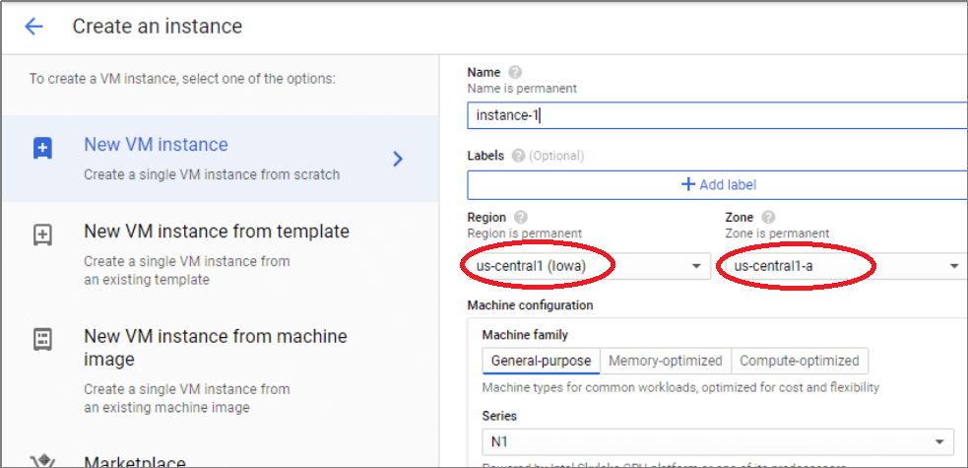

#### 

Select the required machine type based on the requirement. A General Purpose VM can work for Windows Server instances. On the other hand, higher workloads such as databases demand memory-optimized VMs.

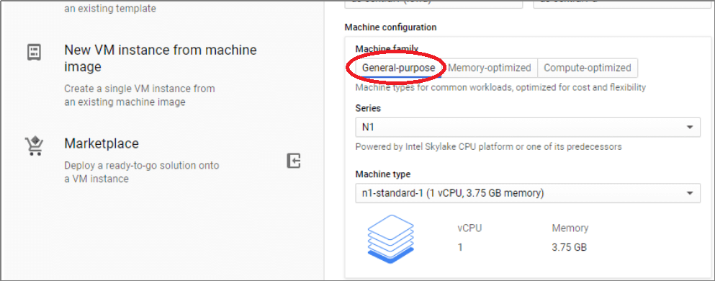

#### 

Select the ‘Boot Disk’ by selecting the required operating system. As a ‘Windows Server’ is being created, click the ‘Change’ button.

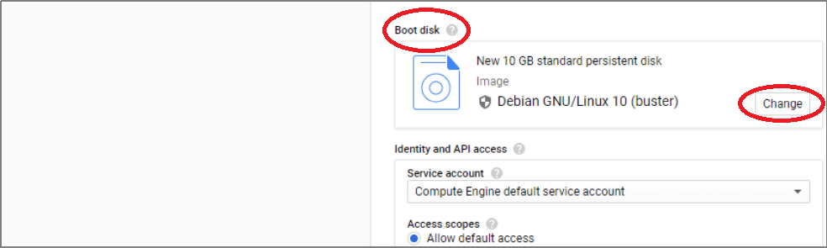

From the ‘Boot Disk’ pop-up window, select the ‘Operating System’ as ‘Windows Server’ and ‘Version’ as ‘Windows Server 2019 Datacenter Core’ and click on the ‘Select’ button.

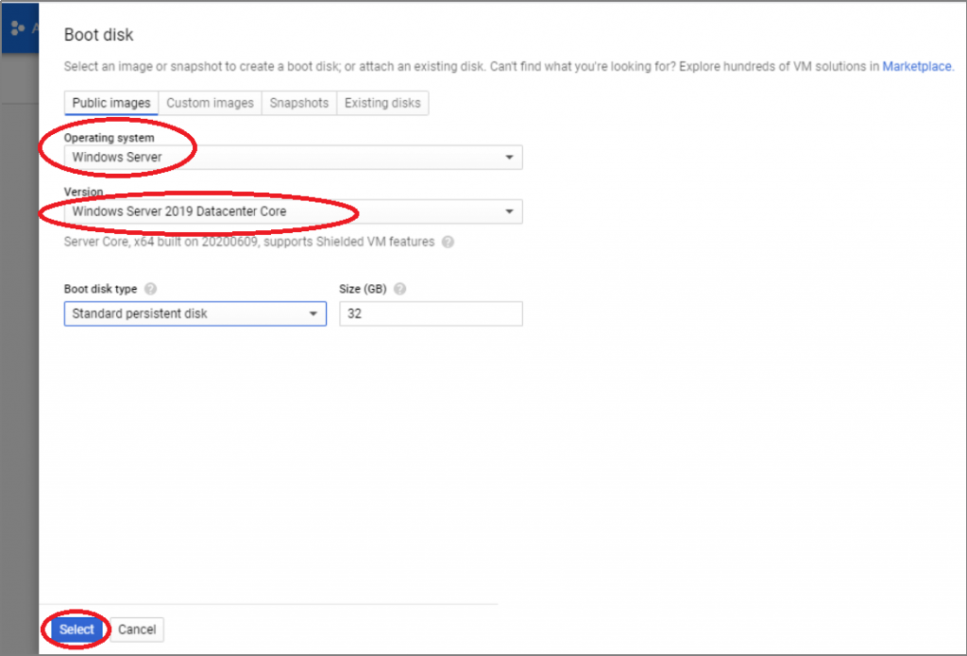

#### 

Select if API access and Firewall exceptions are needed. These are optional choices. Access can be given to a VM to a specific group, individual, or everyone in the organization. Application development primarily needs API access. The firewall settings will dictate whether the VM will be accessible via internet protocols HTTP and HTTPS.

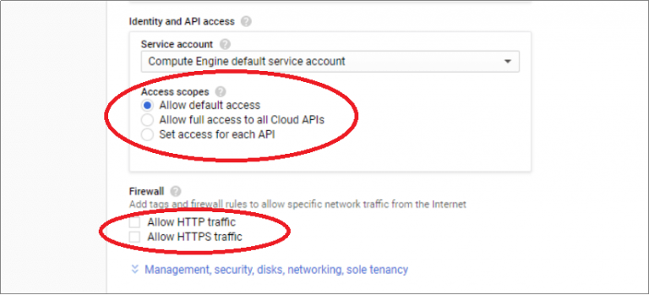

#### 

Click on the ‘Create’ button. The VM creation and deployment process will take a few minutes.

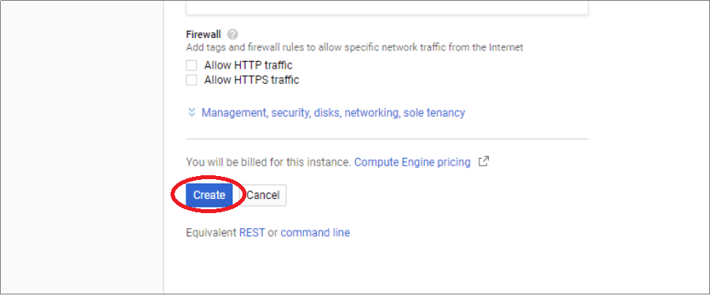

The created VM is listed on the Google Cloud Platform console page.

**Task 2: Identifying the similar services in different cloud platforms**

